35.23: a) The distance from the central maximum to the first minimum is half the distance to the first maximum, so:
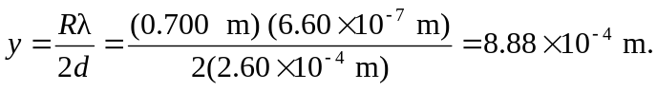
b) The intensity is half that of the maximum intensity when you are halfway to the first minimum, which is 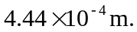Remember, all angles are 

